Enclosed Rhyme

🔹 What is Enclosed Rhyme
# Source: AI Source: Provided by: [Data Path: Persons Table -> ID Column: 1, Name_En Column: Motasem Essam] -> From: [Chatgpt (GPT-4-turbo)] on [8/2/2025]
⚠️ Enclosed rhyme (also called envelope rhyme) is a poetic rhyme scheme, not a type of homograph.
However, homographs can appear in enclosed rhyme if they are used with the same pronunciation.

✅ Definition of Enclosed Rhyme
# Source: AI Source: Provided by: [Data Path: Persons Table -> ID Column: 1, Name_En Column: Motasem Essam] -> From: [Chatgpt (GPT-4-turbo)] on [8/2/2025]
Enclosed rhyme is a rhyme scheme in a quatrain (4-line stanza) where the first and fourth lines rhyme, and the second and third lines rhyme.
🟩 Pattern: ABBA

🧠 Key Features
# Source: AI Source: Provided by: [Data Path: Persons Table -> ID Column: 1, Name_En Column: Motasem Essam] -> From: [Chatgpt (GPT-4-turbo)] on [8/2/2025]
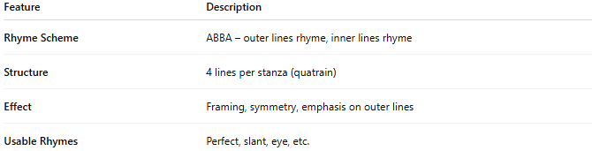
Feature | Description
Rhyme Scheme | ABBA – outer lines rhyme, inner lines rhyme
Structure | 4 lines per stanza (quatrain)
Effect | Framing, symmetry, emphasis on outer lines
Usable Rhymes | Perfect, slant, eye, etc.

📝 Example of Enclosed Rhyme (ABBA):
# Source: AI Source: Provided by: [Data Path: Persons Table -> ID Column: 1, Name_En Column: Motasem Essam] -> From: [Chatgpt (GPT-4-turbo)] on [8/2/2025]
A: The wind blew fierce without a sound
B: Beneath the sky of ashen gray
B: The birds took flight and flew away
A: Their feathers lost upon the ground
- wind / ground = rhyme (A lines)
- gray / away = rhyme (B lines)
✅ This is an enclosed rhyme.

🧪 Using Homographs in Enclosed Rhyme
# Source: AI Source: Provided by: [Data Path: Persons Table -> ID Column: 1, Name_En Column: Motasem Essam] -> From: [Chatgpt (GPT-4-turbo)] on [8/2/2025]
Homographs may appear at line ends in ABBA if their pronunciation matches and fits the rhyme.
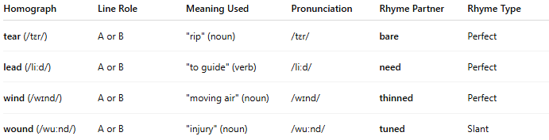
Homograph | Line Role | Meaning Used | Pronunciation | Rhyme Partner | Rhyme Type
tear (/tɛr/) | A or B | "rip" (noun) | /tɛr/ | bare | Perfect
lead (/liːd/) | A or B | "to guide" (verb) | /liːd/ | need | Perfect
wind (/wɪnd/) | A or B | "moving air" (noun) | /wɪnd/ | thinned | Perfect
wound (/wuːnd/) | A or B | "injury" (noun) | /wuːnd/ | tuned | Slant
❗ Homographs do not rhyme if they are pronounced differently.

📊 Comparison of Rhyme Schemes
# Source: AI Source: Provided by: [Data Path: Persons Table -> ID Column: 1, Name_En Column: Motasem Essam] -> From: [Chatgpt (GPT-4-turbo)] on [8/2/2025]
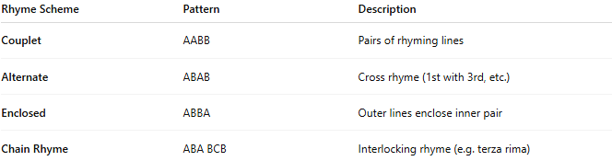
Rhyme Scheme | Pattern | Description
Couplet | AABB | Pairs of rhyming lines
Alternate | ABAB | Cross rhyme (1st with 3rd, etc.)
Enclosed | ABBA | Outer lines enclose inner pair
Chain Rhyme | ABA BCB | Interlocking rhyme (e.g. terza rima)

✅ Summary
# Source: AI Source: Provided by: [Data Path: Persons Table -> ID Column: 1, Name_En Column: Motasem Essam] -> From: [Chatgpt (GPT-4-turbo)] on [8/2/2025]
- Enclosed rhyme (ABBA) places a rhyme on the first and last lines of a 4-line stanza.
- Homographs may be used if they rhyme by sound, not spelling alone.
- Works well with perfect, eye, or slant rhymes using homographs.

